
Tom Atkinson
Funk Star Drummer
Rock Star Developer
Rosebank Road, Avondale, Auckland, NZ
linkedin.com/in/tomatkinson tomachi.co/about/hire-me
tom@tomachi.co
021 257 6422

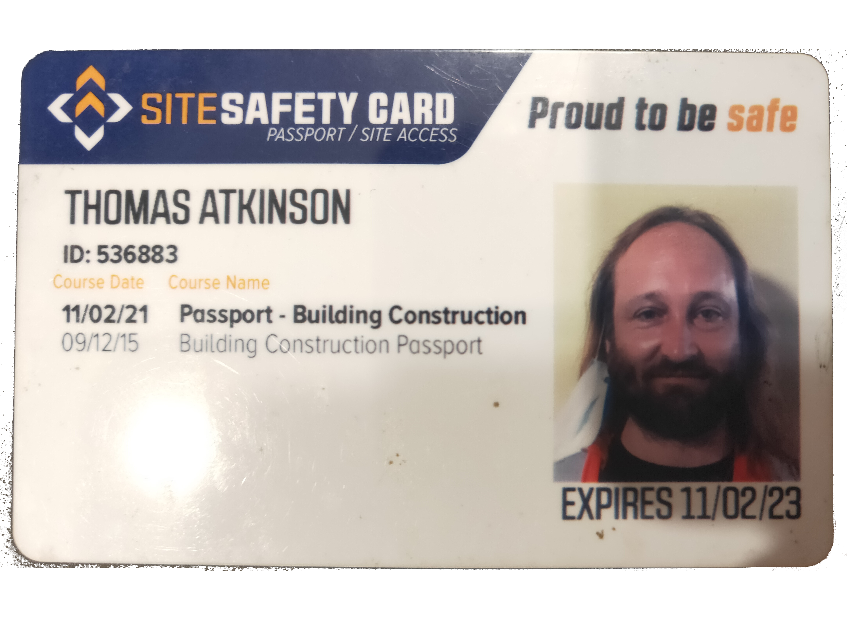
“A jack of all trades, but a master of none, is probably better than a master of one.”
An eternal optimist, a self-taught computer science 1998 drop-out, internet pioneer, one time online marketing consultant and now... fresh 2025 graduate of a Diploma in Digital Technology Development and Design from Mission Ready HQ, hoping to unleash my new-found React / NodeJS skills to the market.
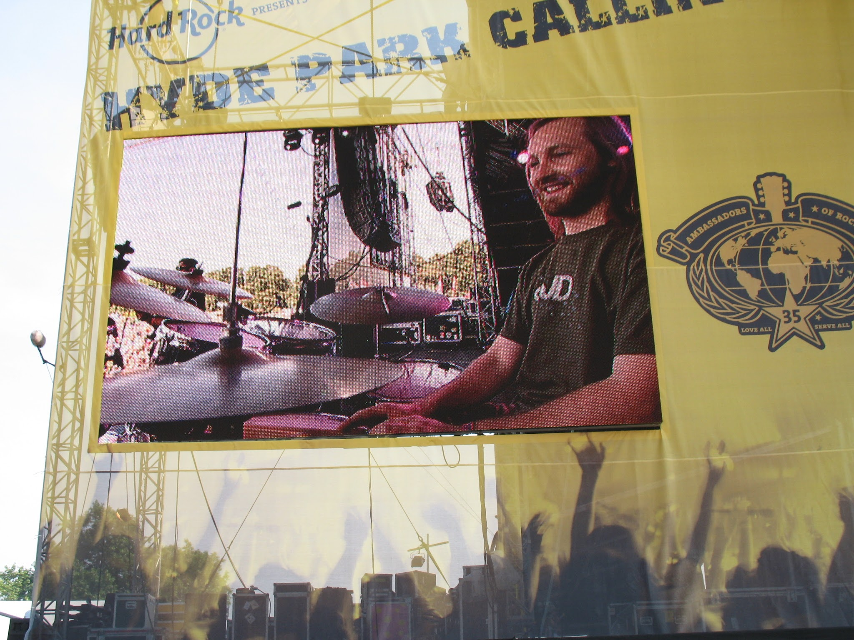
The Full Stack Developer Accelerator program gives me valuable experience using the current industry standard software stacks – typically NodeJS or PHP backend with with an SQL or MongoDB datastore coupled with a frontend built either from raw HTML and Javascript or usually a framework such as React, VueJS, Ember or Svelte. Use of DevOps tools such as Docker, Github, Figma, and Trello was also covered. Prior to COVID-19 I was integrating the API of The Rock Factory’s WordPress / WooCommerce site via Zapier with the CurrentRMS rental management system.
Key Skills
- Diploma in Digital Technology Development and Design 2025 Mission Ready NZQA
- A great passion for the art of complex software design and computer science
- NodeJS, Vue, Svelte and React Full-stack JavaScript Developer
- 8 years experience online marketing, SEO, Google Analytics, Adwords, Yahoo, Bing
- GAIQ and Google Ads certified three times during 2007-2013
- Advanced use of hand-coded JavaScript, HTML, CSS and WordPress CMS
- Experience with PHP, Python, Apache, Nginx, MySQL, Monogdb and Linux admin
- Master of Adobe Creative Suite and general net ninja 1998-2006
- Pro drummer, pianist and producer with 7 albums and 4 international tours
- Full motorcycle and manual car driving license
- 100+ words per minute typing speed (proof)
Employment and Work Experience
Lead Developer The Rock Factory staging and sound hire company
August 2019 – present. Doing WordPress Shop API integration into RMS via Zapier
Lead Dev – AminoSee DNA Viewer – aminosee.funk.nz
2018-2019. Desktop genomics art/science app written in node, a CLI and web UI.
“I can see it now – I can AminoSee It!”

Fullstack Developer – CrowdCourier – crowdcourier.cc
September 2017 – 2019. A social delivery network / mobile job dispatch app
“Let your customers by your courier!”
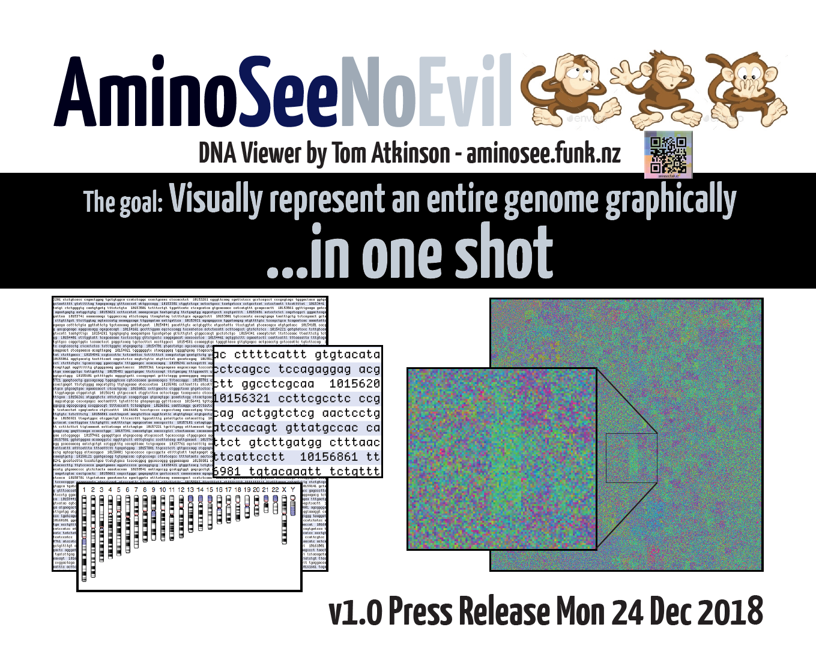
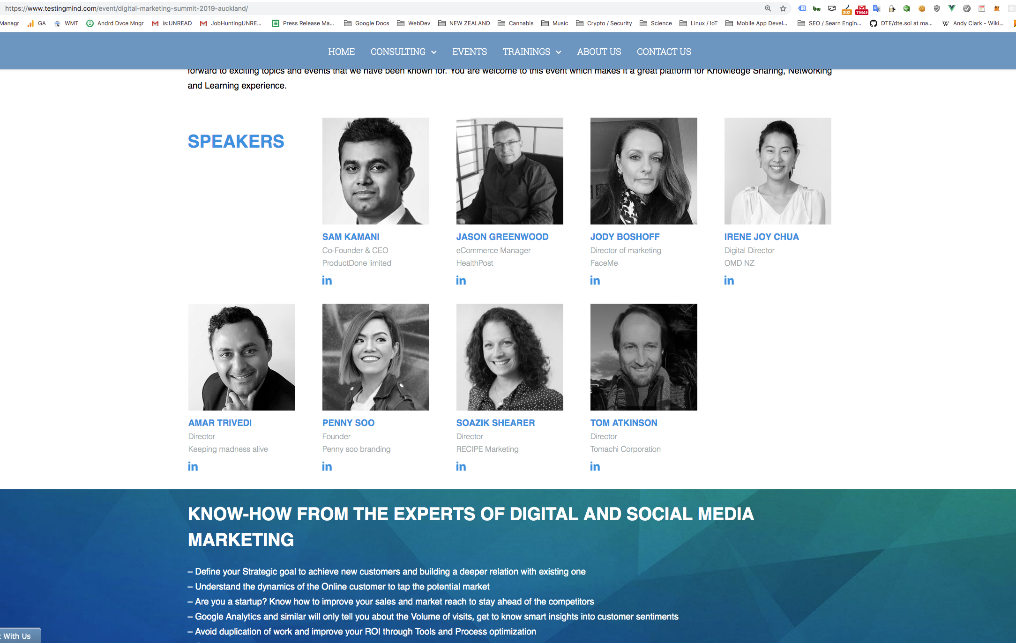

Fullstack Developer – Tomachi Corporation – tomachi.co
February 2014 – 2018 - Web Consulting
Freelance web dev, e-Business Consultant, A/V Production, Blockchain
V energy drink for Young+Shand agency – v.co.nz (ReactJS)
Solar Network NZ – solarnetwork.nz (WP site and forum)
Student Internships NZ – internships.co.nz (ecommerce WP site)
Aspire Property Management – aspireproperty.co.nz (Google Ads)
Big Brands Online – bigbrandsonline.co.nz (devops)
Playtech – playtech.co.nz (Google Analytics)
Awaken Direct Democracy Project – awaken.guru (NodeJS development)
LendingTalk – lendingtalk.nz (WP site setup)
Raven Arts Ltd - stock options – raven.tomachi.co (contract writing)
ॐ Aum Productions – aum.co.nz (WP site setup)
Responsive HTML homepage redesign – funk.co.nz (high-end html5 layout)


Senior Digital Marketing Consultant – Pure SEO – www.pureseo.co.nz
March 2013 – February 2014 A small business “Whitehat SEO” and Adwords shopaa
Online Marketing Manager – Stray and Spaceships www.straytravel.com
September 2011 – December 2012 “Boss of traffic enlargement”
Freelance Web Work
June 2011 – September 2011 Local Business Consulting clients Spooksworld, Dramarama, Mello Café, Liquorbox Wine, Ballantyne Taylor, Localist, ClickThrough SEO
Online Marketing Manager – Search Republic www.searchrepublic.co.nz
January 2010 - June 2011 Initially Adwords Specialist, promoted to Online Marketing Manager Responsible for over $1M+ Google Ad spend PA

SEO Manager – Trader Group / ACP Media Ltd – www.autotrader.co.nz
July 2009 – January 2010 6 month contact SEO for Trader Group
Internet Marketing Consultant – First Rate Ltd – www.first-rate.com
2006 – 2009 Search marketing campaign research, setup, maintenance, reporting
Drummer for double-platinum hit group Breaks Co-op 2006 UK, AU, NZ tours, including a 60 date tour of the UK, & supports incl Roger Waters, Winner of Song Of The Year at the New Zealand Music Awards. NZ, Australia, UK and Ireland Tour – funk.nz/breaks
2005 – 2006
Business Computing Tutor – Sir George Seymour College of Travel – sirgeorge.co.nz 2005 – April 2006
Freelance Website Designer
2002 – 2005 Clients: Auckland District Health Board, Paradigm Design, The Learning Curve, Vodafone, Lateral Profiles, and The Hearing House Charitable Trust, Tititiri Matangi Bird Centre – Interactive touch screen bird call memory game: funk.nz/tiri
HTML Production Designer – Advantage Group Ltd
2000 – 2002
Hand-coded static and 100% custom dynamic sites produced from Photoshop artwork:

www.meridianenergy.co.nz
www.sanitarium.co.nz
www.sanitarium.com.au
www.skycity.co.nz
www.waitakere.govt.nz
www.whitepages.co.nz
www.yellowpages.co.nz
www.zfree.co.nz
www.ztalk.co.nz

Web Team – IHUG (dialup ISP) – www.ihug.co.nz (now vodafone.co.nz) 1997 - 2000
Camera operator – Toonz Animation Ltd – Cell-based animation studio. 1995 - 1996


Art Portfolio Site: funk.co.nz
Github Profile github.com/tomachinz
Stack Overflow Profile: stackoverflow.com/cv/tomachi
Recruitment Profile: tomachi.co/about/hire-me
LinkedIn Profile: linkedin.com/in/tomatkinson
Google Ads Certification academy.exceedlms.com/student/award/21752800
Infamous Algorhythm Talk testingmind.com/event/2019-auckland
Qualifications

2025 Diploma in Digital Technology Development and Design
2024 BMI Certified IQ > 63.1% or 105 IQ
2020 LinkedIn Skills: AWS, Git, React.js
2019 Speaker at Beegital Conference
2018 Google Ads Professional
2015 Commercial & Passenger Driving
2015 Site Safe Passport
2013 Google Adwords Professional
2013 Google Engage training event
2011 Google Think:Travel Sydney AU
2011 Google Certified Professional
2009 Google Adwords Professional
2009 Google Analytics Individual Qual
2009 Adobe Flash Forward conf
2008 Search Engine Bootcamp conf
2007 Google Certified Professional
2005 Tutor NZQA Nat Cert Compute
2001 Macromedia ColdFusion
1999 Macromedia Flash 4
1997 Video editing Whitecliffe Col.
1997 Java Programming Auck. Uni.
1995 Bach. VisCom Design Unitec
1995 Silicon Graphics Alias
1994 A Bursary Selwyn College
1994 AIT AutoDeskAnimator
1993 AutoCadR12 Manukau Polytech
NZQA NIN: 111890906

Work Experience
Area of Skill | Skill | Years
Javascript, ES6 | EXPERT | 25
NodeJS, Express, NginX, MongoDB | HIGH | 7
ReactJS / VueJS / MeteorJS | HIGH | 5
LAMP: Linux Apache MySQL, PHP | EXPERT | 18
Google Ads, SEO, Analytics | EXPERT | 12
Grade 8 Music Theory, Piano, Pro Drummer | EXPERT | 29
React Native, Cordova, Native App | GOOD | 2
C# dotnet, Unity Game logic | GOOD | 2
Account Management, Copywriting | HIGH | 6
MySQL / MariaDB / MongoDB | HIGH | 14
MS SQL Server/ Postgresql | GOOD | 14
Svelte, Ember, Angular | GOOD | 3
Google, AWS, IBM, Linode, MS Cloud APIs | GOOD | 5
Logic Audio Production | EXPERT | 24
DevOps, Regular Expressions, Bash | EXPERT | 20
Adobe CS Grapic Design Apps / Premiere Video Editing | HIGH | 20

Matt Batcheldor  Google Agency Liason  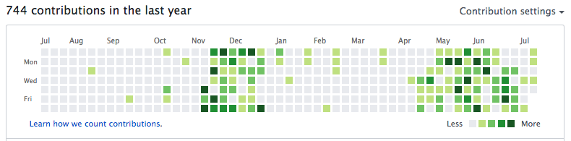  Mike Ballantyne  Director  Search Republic | Justin Cunningham  DMC Freestyle World Champion  Hannah Cornwell  Director Digital Strategy  CrowdCourier.cc | David Craggs  Master Graphic Designer  Kevin Barreau  Fullstack Developer  Young+Shand

